The Rise of Dictatorial Regimes
Section 2
- Who was Benito Mussolini? (540)

- According to Mussolini, what is the Fascist conception of life? (540)

- What was the name of Mussolini’s movement? (540)

- Define totalitarian state. (541)

- How did totalitarian regimes conquer the hearts and minds of their subjects? (541)

- What type of leaders emerged and how did they feel about limited government and rights? (541)

- Where was the first Fascist movement? (541)

- Define FASCISM (541)

- How did economic troubles lead to the rise of Mussolini? (541)

- Who were the Blackshirts, and what did they do? (541)

- What led to the rise of supporters for Mussolini’s fascism? (541)

- How did Mussolini become prime minister? (542)

- What did Mussolini do once he gained power? (542)

- What did people call Mussolini? (542)

- How was the media used by Mussolini? (542)

- Why did Mussolini never achieve the degree to totalitarian control that Hitler and Stalin did? (542)

- Who was the Communist leader of the Soviet Union in 1920? (543)

- How was the economy of the Soviet Union doing in the early 1920s? (543)

- What was the Politburo? (543)

- What does USSR mean? (543)

- Who gained control over the Soviet Union after Lenin’s death? Who was his rival? (543)

- How did Stalin use his position to gain power? (543)

- What were the Five-Year Plans? (544)

- Were the Five-Year Plans successful? (544)

- What was collectivization? (545)

- Describe the Great Purge of the 1930s? (545)

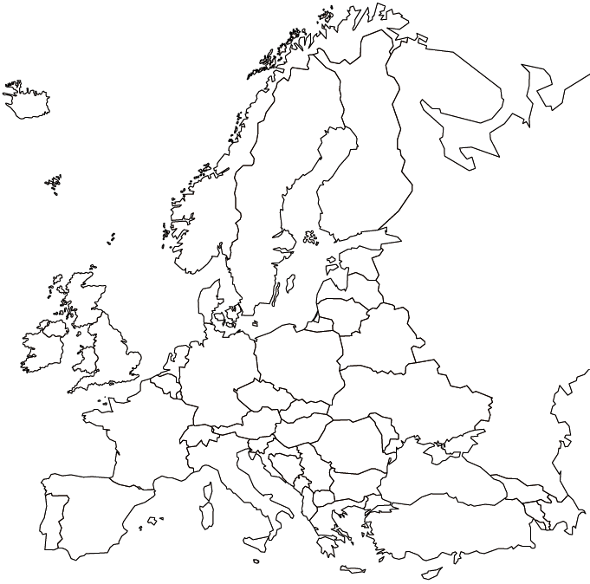

Locate: Russia, France, Italy, Germany, Austria, United Kingdom, and Poland

Locate: Berlin, Moscow, Leningrad, Stalingrad, Paris, Rome, and London

